Sponsor our Shows
As with most community theater groups, ticket sales do not completely cover our production expenses. Therefore, we ask for your support of our productions.
RVCO has 501(c)(3) non-profit status, so your contribution is always tax-deductible. We will list your name, or the name of someone you wish to honor or remember, in our playbill. (Please print this name on the order form.) Alternatively, you may purchase your sponsorship at www.rvco.org.
Sponsor Rates &
Complimentary Tickets
(tickets good for any performance)
Contribution Tickets
Angel $500 10
Star $250 5
Benefactor $150 3
Patron $100 2
Friend $50 1

For Sponsor information,
contact us at:
sponsorship@rvco.org
Deadline for Playbill listing:
Friday, April 3, 2025

Advertise in our Playbills
We have a loyal and growing audience. Your advertisement will be seen by more than 500 potential patrons during the run of our show.
Our playbill is printed in black and white, so black and white ad copy is preferred, although we will accept color copy. Your form and payment must be postmarked by the date below for your ad to run. Please send your ad copy in photo format (.jpg, .gif, .png, .tif) by email to: ads@rvco.org
Advertisement Rates &
Complimentary Tickets
(tickets good for any performance)
Advertisement Size Cost Tickets
Inside Cover (7.5"H x 4.5"W) $200 4
Full Page (7.5"H x 4.5"W) $150 3
Half Page (3.6"H x 4.5"W) $100 2
Quarter Page (1.8"H x 4.5"W) $75 1

For Advertising information,
contact us at:
ads@rvco.org

Deadline for Playbill listing:
Sunday, March 29, 2025

I want to advertise in the playbill:
Inside Cover $200
Full Page $150
Half Page $100
Quarter Page $75
I want to be a sponsor:
Angel $500
Star $250
Benefactor $150
Patron $100
Friend $50

Sponsor Name:
(for playbill)
_______________________________________________
o in honor o in memory

Total Amount Paid: $
Name:
Address:

City/State/ZIP:
Telephone:
Email:

Make checks payable to:
ROSE VALLEY CHORUS & ORCHESTRA
Send payment with this form to:
Attn: Playbill Ads and Sponsors
Rose Valley Chorus & Orchestra
P.O. Box 414
Media, PA 19063
Spring 2026
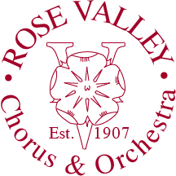
All performances will be at:
The auditorium at
STRATH HAVEN MIDDLE SCHOOL
200 S. Providence Road
(Route 252)
Wallingford, PA 19086

For tickets, go to our website:
www.rvco.org

or call
484-891-9801
(This is recorded information and our voicemail)

Please support RVCO as a
Sponsor or Advertiser!

Rose Valley Chorus and Orchestra
P.O. Box 414
Media, PA 19063
Return Service Requested
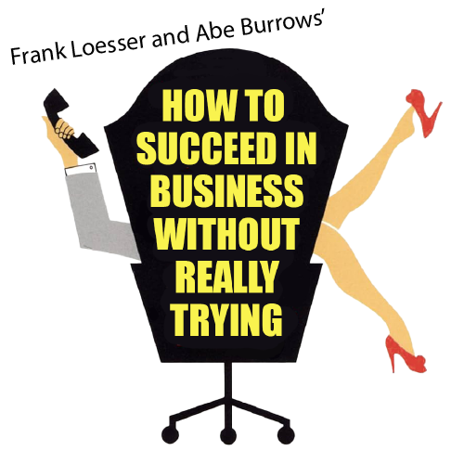

Book by Abe Burrows, Jack Weinstock and Willie Gilbert
Music and Lyrics by Frank Loesser
Based upon the book by Shepherd Mead

Performance Dates:

April 18, 19, 25, & 26 at 2pm
April 18, 22, & 25 at 7:30 pm

Stage Direction
Chris Fitting

Music Direction
Florrie Marks

